
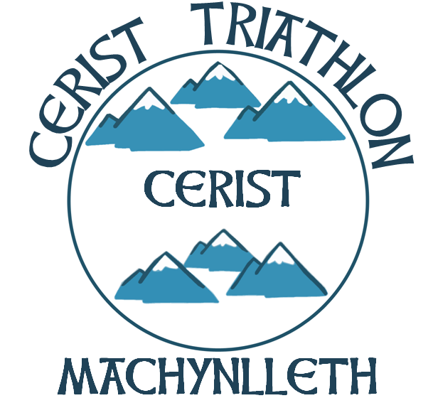
British Triathlon Volunteer Job Description

Volunteer Job Title | Club Chairperson
Type of Volunteering | To act as Chairperson on your club committee.
Main Purpose of Volunteering | To ensure good quality communication channels between your club, its members and your regional committee. To also ensure the smooth running of the club and liaise with other committee members.
Responsible to | The members of your club and other committee members.
Competencies / Experience required | Be organised, diplomatic and have good communication skills. Also be confident in chairing meetings.
Commitment required | Approximately 8-12 x 1 hour meetings per year, plus supporting your club if and when they hold any events.
Benefits to self | Working closely with other committee members, occasionally your regional committee and seeing improved organisation and development within your Region.
Benefits to community | Benefits of a well organised, efficient club committee.
Support received from: | Your committee, your regional committee when necessary and your Regional Development Officer if appropriate.
Is this Volunteer Opportunity open to disabled persons? | Yes.

